**Practical 8 (Pending Intent& Notification)**

**Question 1 (Pending Intent)**

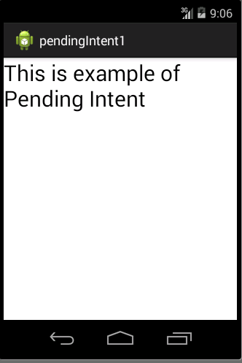

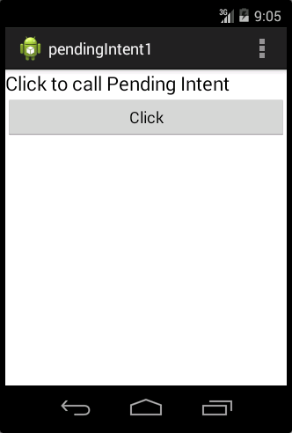

1. Your **activity_main.xml** file should have something similar to xml below: **(p/s: You do not need to follow the xml as it might be different in each design.)**

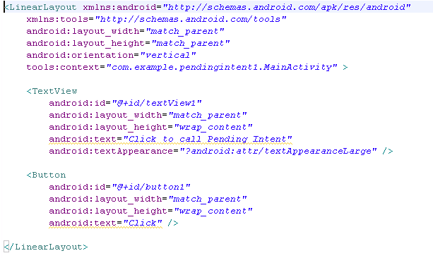



1. Create another file called **activity2.xml in /res/layout.** You should create the interface which similar to the following.

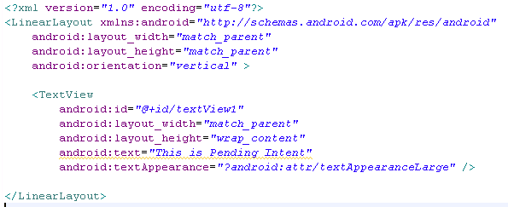



1. In your **MainActivity.java**, code the following code segment to provide function to the button created in activity_main.xml.

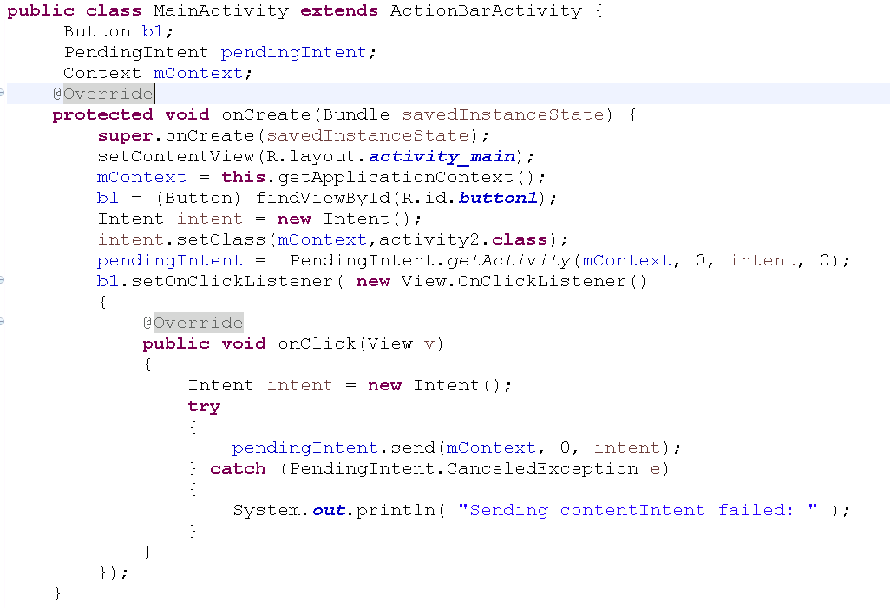

1. Create a class called **activity2.java**.

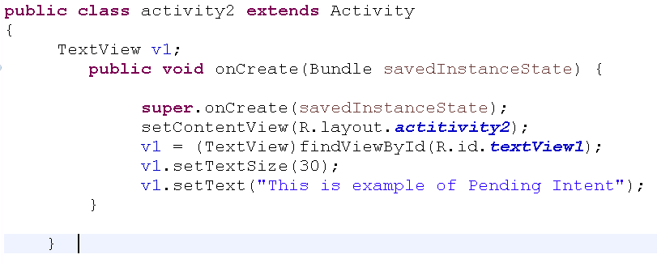

1. Make sure that you add the activity2 in your Android Manifest.
2. After make sure all the coding appropriate done, you may compile and run your coding .

**Question 2 (Notification)**

1. In this question, you are required to create an app with the following interface.

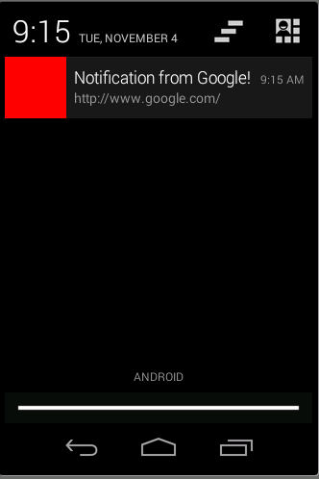

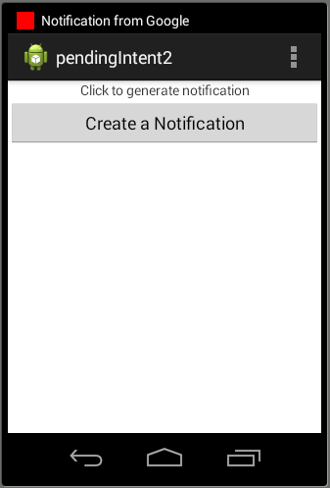

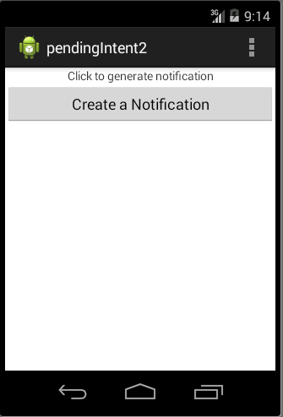

1. Your **activity_main.xml** file should have something similar to xml below: **(p/s: You do not need to follow the xml as it might be different in each design.)**

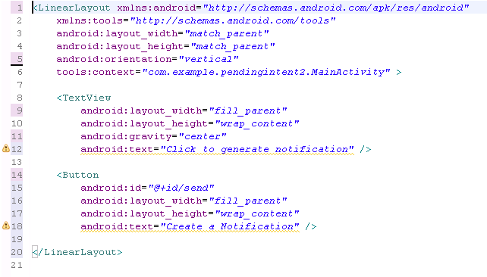



1. In your **MainActivity.java**, code the following code segment.

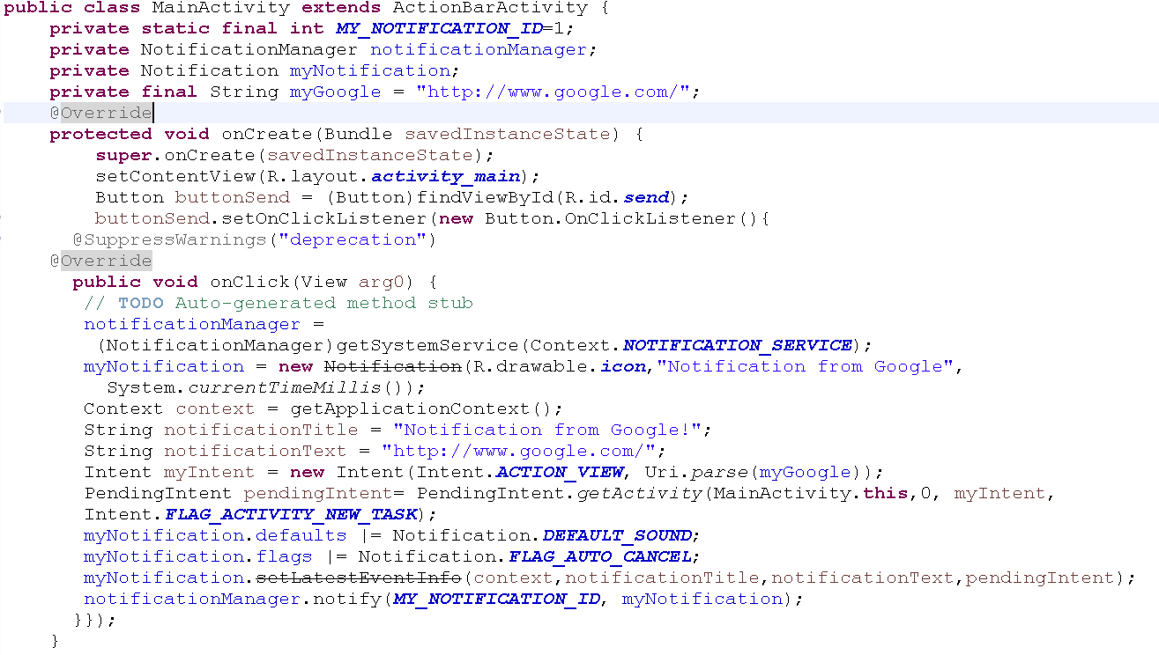

1. After make sure all the coding appropriate done, you may compile and run your coding .

**Question 3(Basic Alarm Clock)**

1. In this question, you are required to create an app with the following interface.

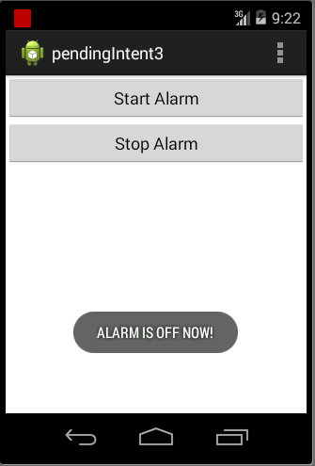

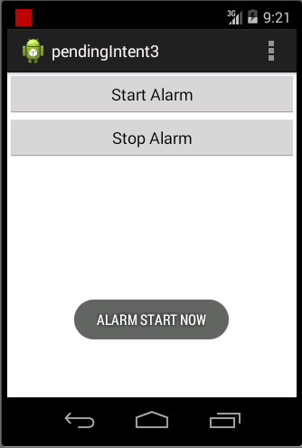

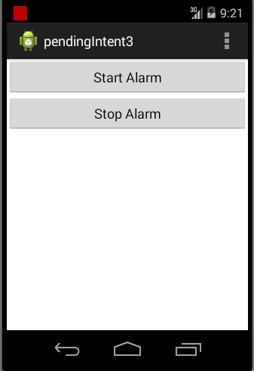

1. Your **activity_main.xml** file should have something similar to xml below: **(p/s: You do not need to follow the xml as it might be different in each design.)**

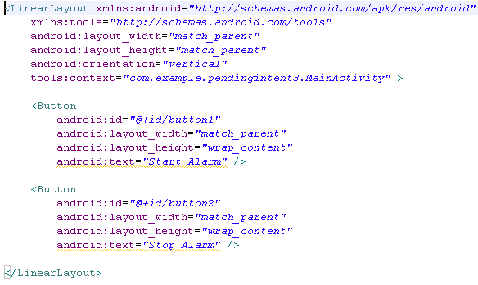



1. In your **MainActivity.java**, code the following code segment.

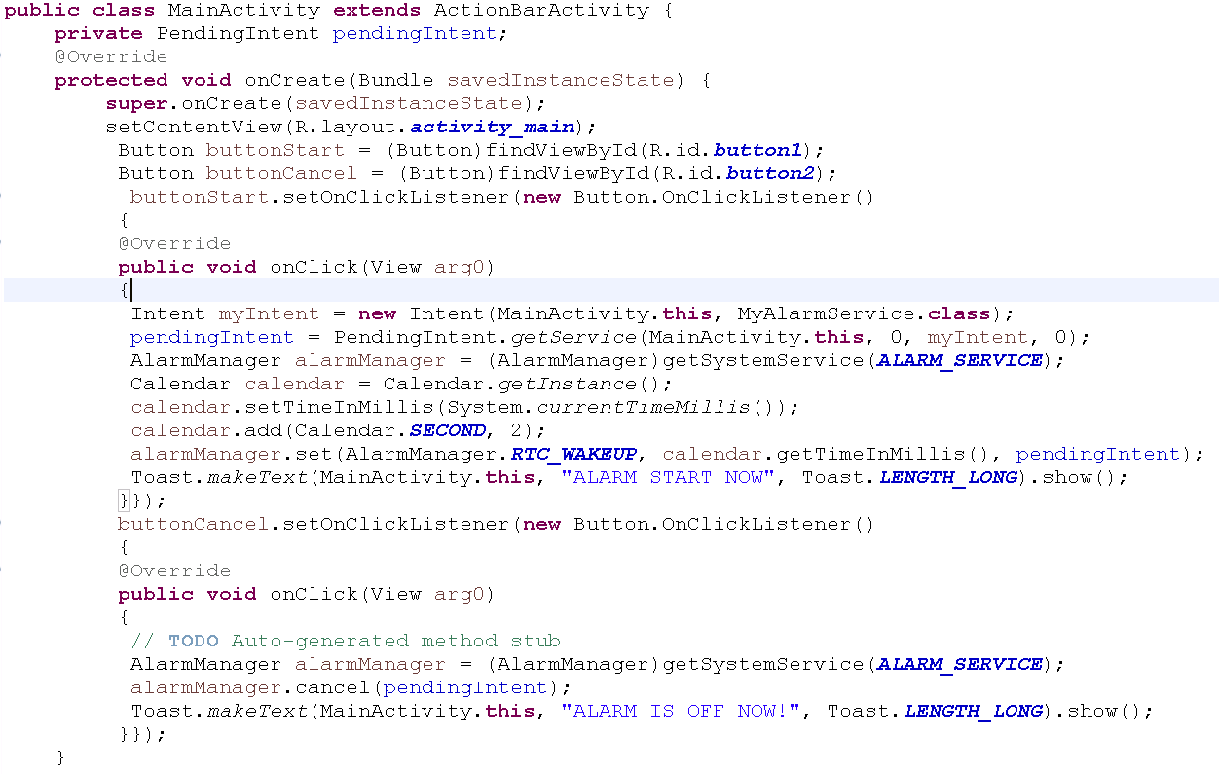

1. **MyAlarmService.java**

**public** **class** MyAlarmService **extends** Service

{

**public** **void** onCreate()

{

// **TODO** Auto-generated method stub

Toast.*makeText*(**this**, "MyAlarmService.onCreate()", Toast.***LENGTH_LONG***).show();

}

@Override

**public** IBinder onBind(Intent intent)

{

Toast.*makeText*(**this**, "MyAlarmService.onBind()", Toast.***LENGTH_LONG***).show();

// **TODO** Auto-generated method stub

**return** **null**;

}

@Override

**public** **void** onDestroy()

{

// **TODO** Auto-generated method stub

**super**.onDestroy();

Toast.*makeText*(**this**, "MyAlarmService.onDestroy()", Toast.***LENGTH_LONG***).show();

}

@Override

**public** **void** onStart(Intent intent, **int** startId)

{

// **TODO** Auto-generated method stub

**super**.~~onStart~~(intent, startId);

Toast.*makeText*(**this**, "MyAlarmService.onStart()", Toast.***LENGTH_LONG***).show();

}

@Override

**public** **boolean** onUnbind(Intent intent)

{

// **TODO** Auto-generated method stub

Toast.*makeText*(**this**, "MyAlarmService.onUnbind()", Toast.***LENGTH_LONG***).show();

**return** **super**.onUnbind(intent);

}

}

1. After make sure all the coding appropriate done, you may compile and run your coding .

**Question 4(Create Notification)**

1. Create an app to create notification. In this question, you should create an interface to allow user to set their notification title, subject and also content. Once the user click on the button, the notification should be created.

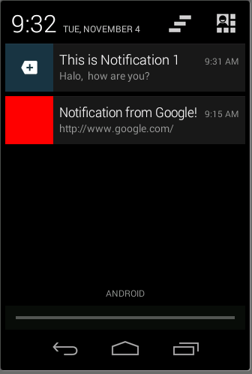

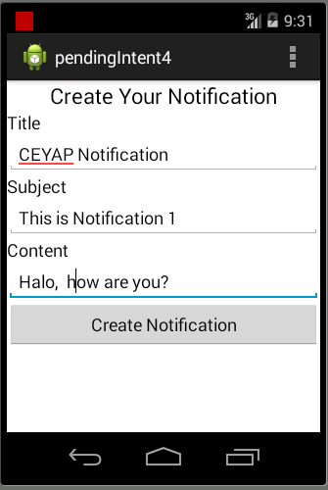

**Question 5**

Base on the understanding from Question 3, You should create an alarm clock app which includes the following features for your homework:

1. **Set Time**

Allow the user to set their wake up time using dialog. You can use the DatePickerDialog and also TimePickerDialog. Once the time reach, you should then generate the notification to notify the user.

1. **Turn OFF alarm**

In this function, you should allow the user to turn off the alarm using one of the options:

1. Solve mathematics problem
2. IQ test